{Application Form Explanatory Letter}

Dear Student,
You have an opportunity to apply for participation in the Tolle Lege Summer Institute on the campus of Borromeo Seminary. This five-day overnight camp is for junior class students who are entering their senior year of high school. It will have two sessions which will take place June 16th – 21st and June 23rd - June 28th, 2024. The camp will focus on specific areas of philosophy and theology and their relation to our Catholic faith. Classes in these areas will be taught by members of the seminary faculty, and there will be other opportunities for learning as well. You can also expect a host of fun activities, including a bonfire, a baseball game, and a field trip to the Art Museum.
Our name, Tolle Lege, comes from the account of the noted Christian bishop and philosopher of the 4th century, St. Augustine, who tells of the divine call he received to a conversion of life entirely to the service of God. St. Augustine heard the voice of a child telling him, “Tolle lege,” or, “Take up and read,” and immediately St. Augustine picked up a copy of St. Paul’s Epistle to the Romans to read, and from that point he committed himself to a life lived for God, becoming a priest and ultimately a bishop and one of the most renowned Christian philosophers.
In the tradition of St. Augustine’s love for learning and wisdom, we encourage you to attend the Tolle Lege Summer Institute to grow in your understanding of the Catholic Church and the truths that St. Augustine, St. Albert the Great, St. Thomas Aquinas, and many others have dedicated themselves to understanding and teaching.
Because of the intellectual nature of the Tolle Lege Summer Institute, students who wish to attend the camp must have maintained a cumulative GPA of 3.0 or higher during their previous three years in high school. If you are interested in learning more about your faith, having a good time, and growing in an understanding of Christian virtue, truth, and spirituality, fill out our application form (found on our website), including the recommendation sheet from your pastor and youth minister.
Send completed form to the Tolle Lege Summer Institute at Borromeo Seminary at: 28700 Euclid Ave., Wickliffe, Ohio, 44092. The cost of the five-day camp is $300 due upon acceptance. Scholarships will be available based on need. If you have any questions don’t hesitate to email us at: tollelegecamp@gmail.com or call us at: (440) 943-7890. Download application forms at our website: www.tollelegecamp.com Follow us on Twitter and Instagram @TolleLegeCamp and visit our Facebook page: Tolle Lege Summer Institute at Borromeo Seminary. Application forms are due May 31st, 2024.
COVID-19 Disclaimer: Tolle Lege Summer Institute is committed to keeping our students healthy and safe. Our staff has intensified protocols and sanitation in response to COVID-19 following all CDC guidelines. We will continue to monitor the situation as we move closer to our sessions. Please do not hesitate to reach out to us if you have any questions or concerns.
Hoping to see you in June!
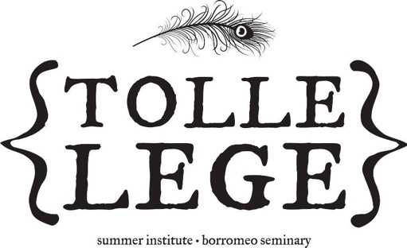
The Tolle Lege Summer Institute
Borromeo Seminary

Full Name: Preferred Name: Date of Birth: _____________
{Application Form}
Street Address: _____________ ____ City: ____________________ Zip Code: ______________
Home Phone Number: __ Cell Phone Number:_________
Email Address: _______________
Parish: ________ Pastor: _______
Youth Minister (if applicable): _______________
High School: _______________
GPA(Cumulative): Shirt Size: How did you hear about us?______________________________
Sex: Male Female Camp Week Preference: Session I (June 16th-21st) | Session II (June 23rd-June 28th)
What is the most interesting book you have read recently and why was it interesting?
________________________________________________________________________________________________________________________________________________________________________________________________________________________________________________________________________________________________________________________________________________________________________________________________________
List any academic honors you have earned during high school, clubs, school involvement, sports:
________________________________________________________________________________________________________________________________________________________________________________________________________________________________________________________________________________________________________________________________________________________________________________________________________
Why do you want to attend the Tolle Lege Summer Institute? (one paragraph)
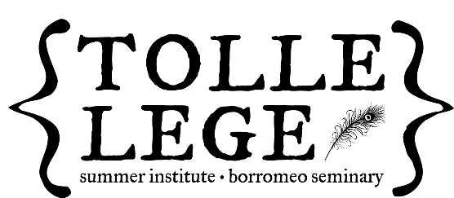
____________________________________________________________________________________________________________________________________________________________________________________________________________________________________________________________________________________________________________________________________________________________________________________________________________________________________________________________________________________________________________________________________________________________________________________________________________________________________________________________________________________________________________________________________________________________________________________________________________________________________________________________________________________________________________________________________________________________________________________________________________________
Please send completed application to:
Tolle Lege Summer Institute
28700 Euclid Avenue
Wickliffe, OH 44092

*Please do not send any payment with the application*

